Experiment No. 6

Title:
Use string functions and regex for email validation, data extraction, and text analysis.

Software / Tools Required:
- Visual Studio Code (VS Code)
- Google Chrome (Browser)
- Basic knowledge of HTML5 and modern JavaScript (ES6+)

Theory:
This experiment explores JavaScript string functions and Regular Expressions (Regex) for processing textual data. The core theoretical pillars implemented include:
- JavaScript String Functions: String functions are used to perform operations on textual data. They help in searching, extracting, modifying, and analyzing characters and words within a string.
- Regular Expressions (Regex): Regular Expressions are patterns used to search, match, and validate specific types of text. They are useful for identifying data such as email addresses, phone numbers, URLs, tags, and other structured information.
- Email Validation: Email validation uses Regular Expressions to check whether an entered email address follows a valid email format. It helps identify valid email addresses from textual input.
- Data Extraction: Data extraction involves identifying and retrieving specific information from unstructured text. Regex patterns and string methods can be used to extract email addresses, URLs, phone numbers, tags, and other entities from the given text.
- Text Analysis: Text analysis is the process of examining textual content to obtain useful information such as word count, character count, sentences, paragraphs, reading time, character distribution, and keyword frequency.

AIM OF THE CASE STUDY :
To design and develop an interactive String Functions & Regex Studio using JavaScript that performs email validation, extracts entities from unstructured text, applies string operations, tests regular expressions, and analyzes textual data. The application displays email presence, detected email addresses, word and character counts, sentence and paragraph counts, reading time, character-set distribution, and keyword frequencies dynamically.
Name : Parth Vishnu PRN : 24070521279
File Path : file:///C:/Users/DELL/JavaScript%20lab/jscs6/parth.vishnu.index.html

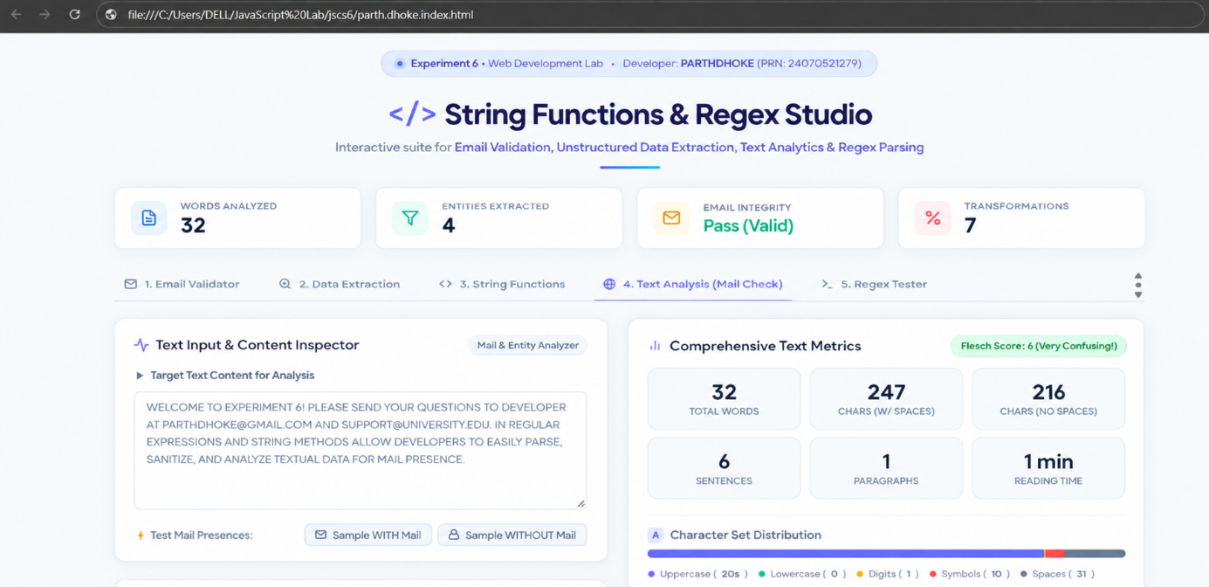

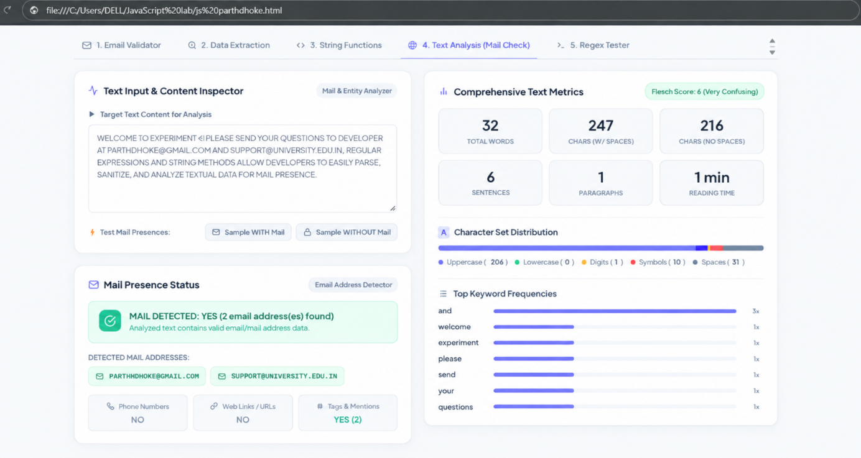

Output :
The String Functions & Regex Studio webpage was successfully displayed. It performs email validation, extracts email addresses and other entities, applies string functions and regular expressions, and analyzes the given text dynamically. The webpage displays the detected mail status, extracted email addresses, text statistics, character-set distribution, and top keyword frequencies.

Result / Conclusion :
In conclusion, this experiment demonstrated the use of JavaScript string functions and Regular Expressions for email validation, data extraction, text processing, and analysis of unstructured textual data. The visual output confirmed the correctness of the script, showcasing accurate detection of email addresses and dynamic updates of text statistics, character-set distribution, and keyword frequencies.

